

**A211 STIA1113 – PROGRAMMING 1 (GROUP C)**

**ASSIGNMENT 1**

**NAME: NOR AISYAH BINTI ABD HALIM**

**MATRIC NUMBER: 286982**

**TOPIC: BANK**

**SUBTOPIC: BUSINESS LOAN**

**LECTURER: PROF. MADYA DR. AZMAN B YASIN**

**SUBMISSION DATE: 19 DECEMBER 2021**

1. **Identify the problem**

Small and mid-size enterprises (SMEs) are businesses that maintain [revenues](https://www.investopedia.com/terms/r/revenue.asp), [assets](https://www.investopedia.com/terms/a/asset.asp) or a number of employees below a certain threshold. Each country has its own definition of what constitutes a small and medium-sized enterprise (SME). Certain size criteria must be met and occasionally the industry in which the company operates in is taken into account as well.

SME finance is the funding of small and medium-sized enterprises, and represents a major function of the general business finance market – in which capital for different types of firms are supplied, acquired, and costed or priced. Capital is supplied through the business finance market in the form of bank loans and overdrafts; leasing and hire-purchase arrangements; equity/corporate bond issues; venture capital or [private equity](https://en.wikipedia.org/wiki/Private_equity); asset-based finance such as [factoring](https://en.wikipedia.org/wiki/Factoring_(finance)) and [invoice discounting](https://en.wikipedia.org/wiki/Discounting), and government funding in the form of grants or loans.

The SME Loan provides a single line of credit for meeting the borrowing needs of SME. It can be used as a working capital as well as for long-term requirements. It is approved after considering the nature of business, cyclical trends, cash flow projections, and peak time requirements.

Maybank is [Malaysia](https://en.wikipedia.org/wiki/Malaysia)'s largest bank by market capitalisation and total assets and [one of the largest banks in Southeast Asia](https://en.wikipedia.org/wiki/List_of_largest_banks_in_Southeast_Asia), with total assets exceeding US$203 billion and having a net profit of US$1.98 billion for 2019.

Maybank is also ranked 106th in The Banker's 2020 Top 1000 World Banks (as at July 2020) and is ranked 349th in the Forbes Global 2000 Leading Companies (as at May 2020).

Maybank is the largest public listed company on Bursa Malaysia, the Malaysian stock exchange, with a market capitalisation of US$23.7 billion as of 31 December 2019.

* Information:

1. Eligibility:
2. Below RM25 million annual sales turnover
3. Below RM5 million outstanding loan/ financing with Maybank
4. Malaysian-owned registered company
5. The rate interest is 4.5%
6. No collateral needed

|  |  |  |
| --- | --- | --- |
|  | Online Application | Branch Application |
| Financing amount | RM10,000 – RM250,000 | RM50,001– RM1,500,000 |
| Approval time | * 10 minutes if you are an existing Maybank customer. * Approximately 48 hours if you are new to Maybank. | Determined on a case-by-case basis |
| Required documents | * No documents required if you are an existing Maybank customer. * If you're new to Maybank: * NRIC of Directors /Shareholders/Proprietors /Partners/ guarantors * Business Registration documents | * NRIC of Directors /Shareholders/Proprietors /Partners/ guarantors * Business Registration documents * Latest 6 months bank statement from any bank |
| Security requirements | None | * Joint and Several Guarantee from all the directors (for Sdn. Bhd. only) * Corporate Guarantee (from Parent companies, if applicable) |
| Financing tenure | Up to 5 years | Up to 7 years |
| Business operation period | Minimum 1 year | Minimum 3 years |

Calculation:

Monthly payment:

Using formula: $\frac{P * i}{1 - \frac{1}{{(1 + i)}^{n * 12}}}$

where

P = loan amount

i = monthly interest in decimal

n = loan term in years

1. **Understand the problem**

Due to Covid-19 pandemic, most of business person having trouble with money because they have to close the store. To prevent from bankruptcy, most of them want get a loan. Due to pandemic, everyone must stay at home and need to make an appointment first to walk in at the branch. The customer has to wait until that day to go to the branch and it will take a lot of time for them to get a loan.

1. **Identify alternative ways to solve the problem**
2. The system will give the information about SME Clean Loan and will calculate the monthly payment for the customer.
3. The system will give information about loan and the customer will make a decision him/herself.
4. **Select the best ways to solve the problem from the list of alternative solutions**

The system will give the information about SME Clean Loan and the qualification to apply that loan. The user will enter the information about him/herself (name, age, number phone), loan amount, duration loan and the system will calculate the monthly payment.

1. **List instructions that enable you to solve the problem using the selected solutions**
2. Use the information from the customers.
3. The system will give information of SME Clean Loan.
4. The customer will choose to applied by online or walk in at branch.
5. The customer will enter the amount of loan and duration loan.
6. The system will calculate the monthly payment based on amount of loan and loan duration and total payment.
7. The system will shows the monthly payment and total payment to the customer.
8. **Evaluate the solution**

In the end by using the system will help the customer to be more understand about business loan and will be easier for the customer to get a loan. SME Clean Loan give many benefits to customer. First, it is easy & quick because nowadays it can be applied online or at branch. Other than that, it has low rates and charges. It is also didn’t need collateral to apply loan. Monthly payment is calculated to help the customer experiment with different loan amounts and loan durations so they can figure out the suitable loan amount they would be able to take out without causing any inconvenience to their finances, and the period of time within which they can comfortably repay the loan.

1. **Algorithm**
2. Start
3. Enter your name, phone number and age.
4. Display information about SME Clean Loan.
5. Enter amount of loan and loan duration.
6. System calculate the the monthly payment and total payment.
7. Display name, monthly payment and total payment.
8. End
9. **Pseudocode**

Start

Output “Enter your name”

Input name

Output “Enter your number phone”

Input number phone

Output “Enter your age”

Input age

Display information about SME Clean Loan

Display eligibility

Display types of application method

Display information about online application

Display information about branch application

Output "The interest rate is 4.5%."

Output "No collateral needed."

Output “Which one do you preferred”

Input preferred

Output "Enter the amount of loan: "

Input amount

Output "Enter the loan duration: "

Input duration

Initialize interest to 0.045

Calculate monthly payment = amount * (interest / 12) / ( 1 - 1 / (1 + (interest / 12 $)^{ duration * 12}$

Calculate total payment = monthly payment * 12 * duration

Output “Monthly payment is RM” and monthly payment

Output “Total payment is RM” and total payment

End

1. **Flow Chart**

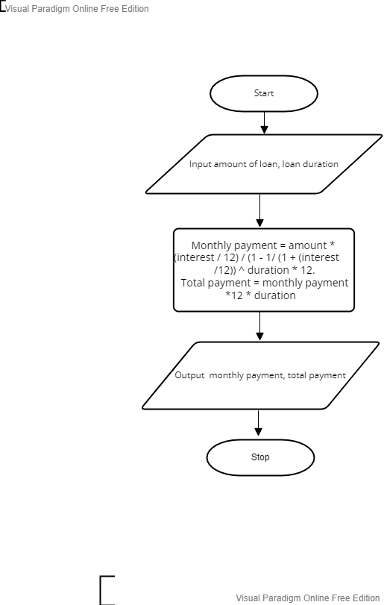

1. **Coding – Numerical Computation & Expression**
2. Coding

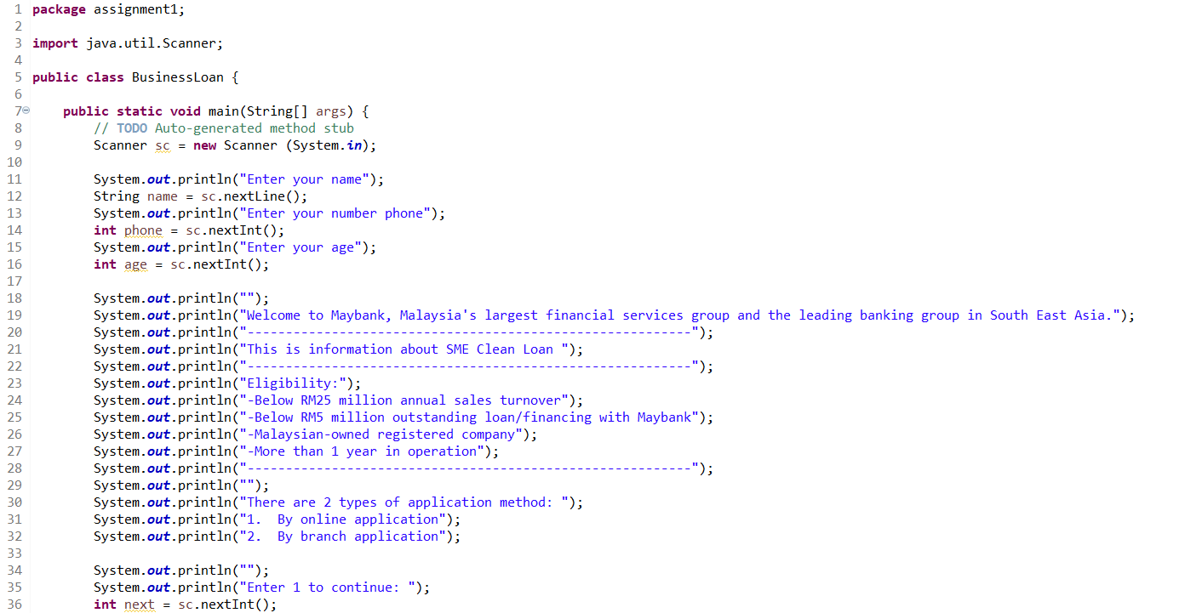

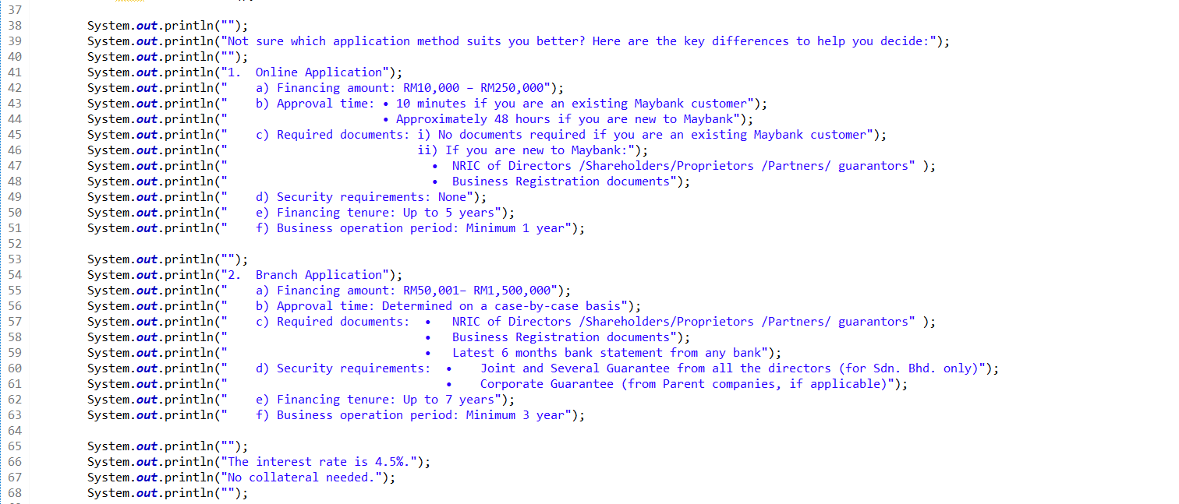

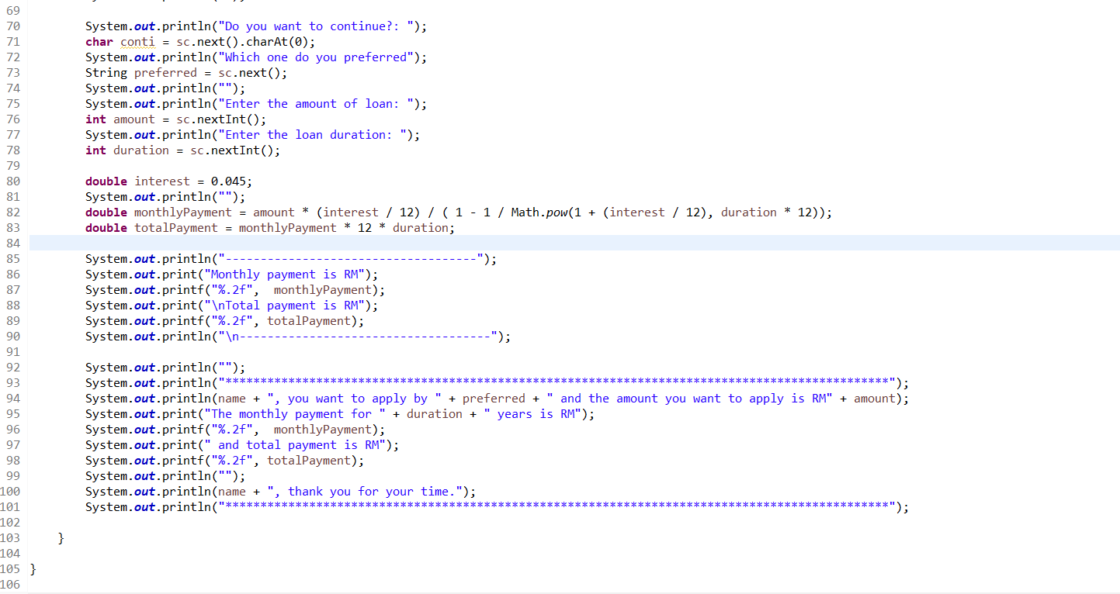

1. Output

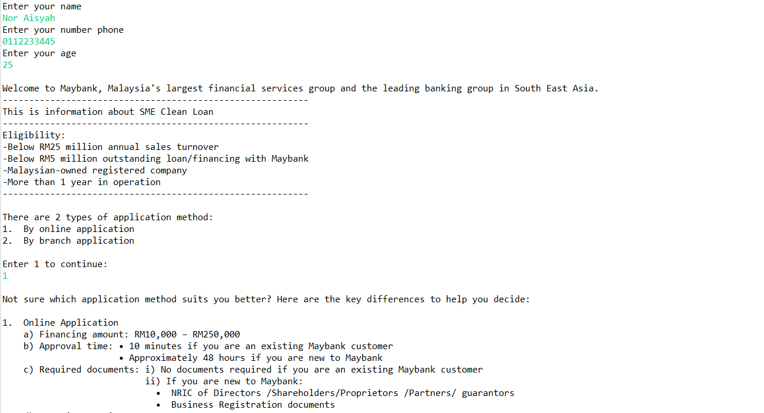

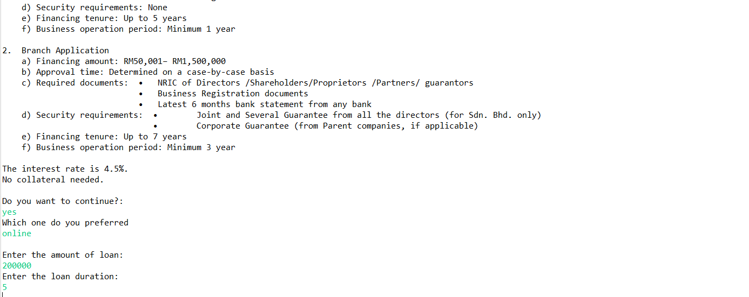



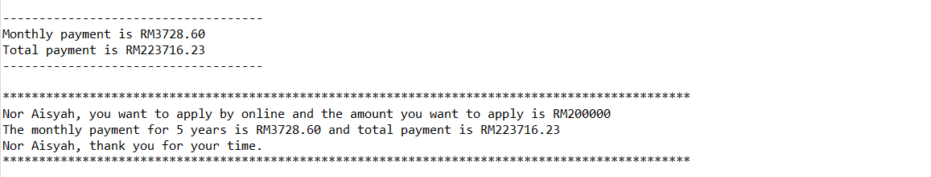



**A211 STIA1113 PROGRAMMING 1 (GROUP C)**

LECTURER : Prof. Madya Dr. Azman B Yasin

NAME : NUR ANIS SHAFIQAH BINTI MAZLAN

MATRIC NUMBER : 286987

TOPIC : BANK

SUBTOPIC : PERSONAL ACCOUNT



Since July 1983, Bank Islam Malaysia Berhad has been operating as an Islamic bank in Malaysia. Bank Islam is Malaysia's first Islamic bank, and it has played a significant role in the creation and growth of the country's Islamic financial system. Our current existence is focused on satisfying society's financial demands in the most sustainable and ethical way possible, while adhering to Shariah regulations and principles.

1. **Identify the problem:**

Encik Karim, a retired teacher from SMK Kubang Kerian, was 62 years old. Encik Karim wanted to pay his electric bill at Bank Islam Kubang Kerian in Kota Bharu, Kelantan, last week. Encik Karim was having problems transferring money to Tenaga Nasional Berhad for pay his house electric bill during the COVID-19 epidemic because people were advised to stay at home to prevent getting the virus. Encik Karim is looking for a solution from Bank Islam Malaysia to help him in paying his electric bill.

1. **Understand the problem:**

Our goal at Bank Islam is to create alternatives for everyone and improve their lives. We accomplish this through offering end-to-end financial systems that fit the various requirements of customers, as well as a platform for our stakeholders to grow, including our people, customers, and community.

According to the problem stated, Encik Karim is having problems paying a bill since he is unable to go to Bank Islam. This implies Encik Karim will have to find another way to pay his electric bill without having to go to Bank Islam.

1. **Identify alternative ways to solve the problem:**
2. Create an online service programme (GO Bank Islam) that requires customers to provide their information and allows them to transfer money via phone or laptop.
3. Contact Bank Islam employees and request that money be transferred by providing customer information.
4. **Select the best way to solve the problem from the list of alternative solutions:**



The first way is the best way that can be easier for Encik Karim to transfer his money. GO Bank Islam online service program can assist customer with their problems relating to the option that are available. A program will provide user information related to Recipient Bank, Recipient Account, Recipient Name, Recipient Reference, Amount. This program will lead the user through the process of transferring money and will calculate the total amount transmitted and any fees that may be charged based on the user's request.

1. **List instructions that enable you to solve the problem using the selected solution:**
2. User need to choose DuitNow.

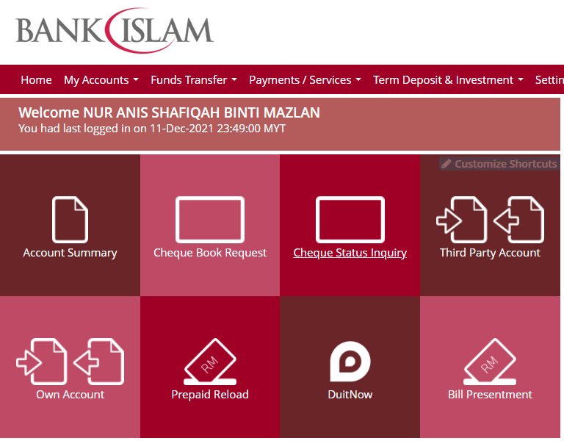

1. Ask user to key in their account number .

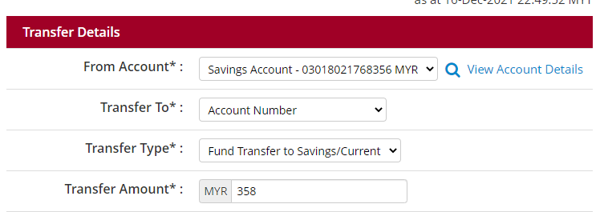

1. The program will display the details needed. (example: Recipient Bank Name, Recipient Account, Recipient Name, Recipient Reference, Amount ).

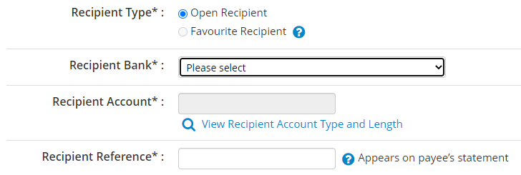



1. Ask user to key in the information needed.
2. The program will calculate the total amount transmitted and fees that have been charged.
3. The program will display the total amount transmitted and fees that have been charged to user.

EXAMPLE :

Account number : 764538

|  |  |  |
| --- | --- | --- |
| OPTION |  | FORMULA |
| DuitNow | Recipient Bank Name : Bank Muamalat  Recipient Account : 63518028  Recipient Name : Salman Bin Aziz  Recipient Reference : For food  Amount : RM176.00  *RM1.00 will be charged.  *Fee = 2% | RM176.00 + RM1.00 + (RM176.00*0.02)  = RM180.52 |

1. **Evaluate the solution**

Based on the solution that have been stated, Encik Karim can pay his electric bill by using GO Bank Islam services and choose DuitNow to transfer the money. Besides, regarding to the situation that Encik Karim or people who need to transfer their money but need to stay at home, also can make transaction money to others by using DuitNow too. They can use it on their phone or laptop at anywhere and anytime.

1. **Algorithm**

1.Choose DuitNow.

2.Insert user account number.

3.Insert recipient bank name.

4.Insert recipient account number.

5.Insert recipient name.

6.Insert recipient reference.

7.Insert transfer amount.

8.Wait until programme finish calculate total amount and fee that been charged.

9.Programme display total amount and fee that been charged.

1. **Pseudocode**

Start

Read next

Read acc

Read bankname1

Read acc1

Read name1

Read reference1

Read amount1

Read next1

Calculate total1 = (amount1+(amount*0.02)+1)

Display total

End

1. **Flowchart**

Read next

Display total

Calculate total = (amount1+(amount1*0.02)+1)

Read next1

Read amount1

Read reference1

Read name1

Read acc1

Read bankname1

Read acc

1. **Coding - Numerical Computation & Expression**

CODING :

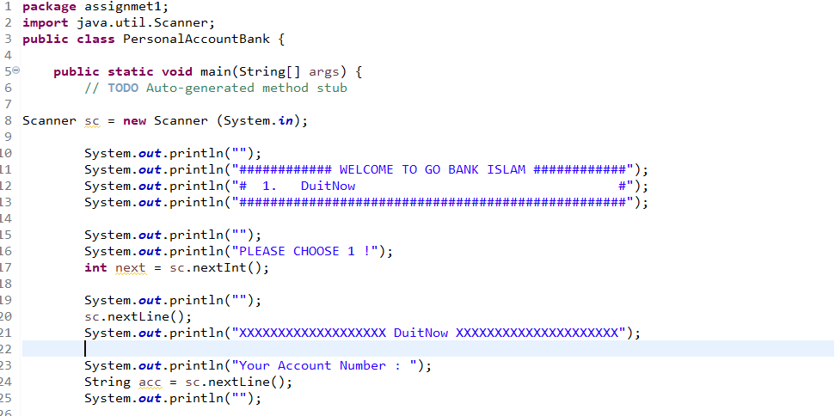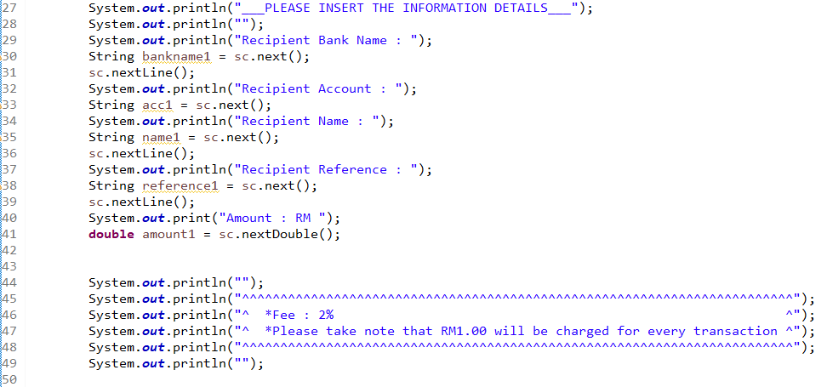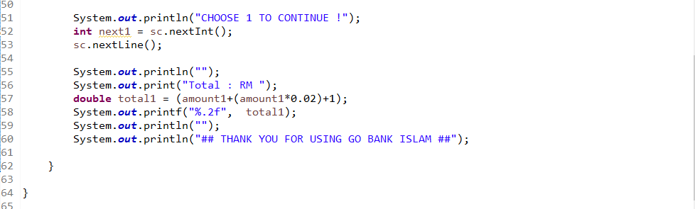

OUTPUT :

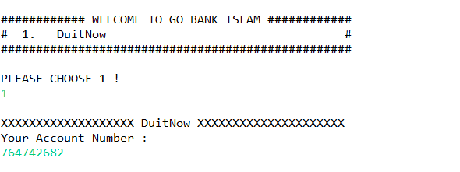

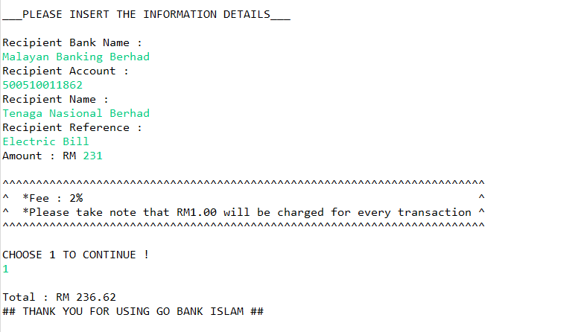

**ASSIGMENT 1:**

**THE UTILITY OF CREDIT CARD**



NAME: MUHAMMAD AFIQ IMRAN BIN AZIZAN

MATRIKS NO.: 286997

UNIVERSITY: UNIVERSITY UTARA MALAYSIA

CLASS: INFORMATION TECHNOLOGI, SCHOOL OF

COMPUTING

LECTURER: PROF. MADYA DR.AZMAN B YASIN

DUE DATE: 12 DECEMBER 2021

**History:**

Credit Card is a plastic containing a means of identification that could make purchase of goods and service with lending money from bank. Credit Card first invented at United State of America in 1920s because it bother company that customer purchase made by company outlets. In 20th century the uses of credit card increasing and almost all people such as university student, teacher, and worker have credit card of their own.

**PROBLEM:**

In today era a lot to be done such as paying debt, buying plane ticket, booking a hotel and a lot more and you didn’t have much money to buy it all. Furthermore, you also didn’t want to bring a lot of money in your wallet because it could be stolen by people or you will get uncomfortable with the big wallet in your pocket. Not only that, you also need to buy things at once but can’t go at one place in a single time.

**UNDERSTANDING THE PROBLEM:**

The problem that you facing is that we don’t have much money to buy things that we want because the things is to expansive or we don’t have much money. Other than that, we don’t want our wallet to be stollen by thief when bring it with a lot of money. Furthermore, You don’t want to feel uncomfortable when bring big amount of money to places because it could make you unease. Lastly you want to purchase things in short amount of time without going many places.

**ALTERNATIVE TO SOLVE PROBLEM:**

One of the alternative that you can take is to make a purchases at home with online banking so that you can pay and buy things faster. Other than that, you can make loan with bank to get money to buy things you want. Plus, you also can bring wallet with big amount of money for example bringing RM 100 instead of RM 50 to make it easier bringing wallet around. Lastly, you can use credit card to buy things online and bring in wallet every time to purchase things.

**BEST ALTERNATIVE:**

Out of all the alternative, the best one is to use credit card to buy things online and bring it in wallet every time to purchase things. The reason why pick this is because it contains the other 3 alternative to solve problem. Not only that credit card also had ability that non purchase don’t have. The thing is called cashback, cashback is an amount of percentage that will be pay back to us from purchasing something with specific type of credit cards. You also need to pay bank monthly because we borrow money from bank and if you didn’t pay them that month the debt will become bigger next month.

**INSTRUCTION:**

1. Enter your name
2. Enter your credit card number
3. Enter expiration date
4. Enter your CCV
5. Purchase the things you want
6. Purchase successful

**TYPE OF CREDIT CARD:**

|  |  |  |  |  |
| --- | --- | --- | --- | --- |
| Type of credit card | Name of credit card | Specialty | picture | Interest rate |
| Type 1 | CIMB e Credit Card | none |  | 15% |
| Type 2 | CIMB Petronas Platinum MasterCard | -Give cashback of 7% on petrol money |  | 15% |
| Type 3 | Bank Rakyat Platinum Explorer Credit Card-i | -Give cashback of 5% on airlines and hotel booking |  | 13.5% |

**CALCULATION:**

|  |  |  |
| --- | --- | --- |
| Type of credit card | calculation | Description |
| Type 1 | -smartphone = 200  -laptop = 3000  -petrol = 50  - airplaneTicket = 4556  -Insurance = 74  -houseDebt = 650  -carDebt = 494  -HotelBooking = 200  -Totalpayment = 2000 + 3000 + 50 + 2556 + 74 + 650 +  494  -monthly payment= (2000/12) + (3000/12) + (50/12) +  (2556/12) + (74/12) + (650/12) +  (494/12)  -current money = 2000  -new money = 2000 + 3500  Money left = new money – monthly payment | -Thers nothing special about credit card type A because it’s just a basic one |
| Type 2 | *same as Type A  -petrol cashback = 50 *0.07  -balance = petrol cashback + new money | -Credit Card Type B will give you back 7% of petrol money in a year |
| Type 3 | *same as Type A  -airplane ticket cashback = (airplane ticket * 0.05) (4)  -hotel booking cashback = ((hotel booking * 0.05) (4)(7))  -last balance = balance 8 + airplane ticket cashback + hotel booking cashback | - Credit Card Type C will give you back 5% of airplane ticket and hotel booking |

**CALCULATION CREDIT CARD WITH DEBT:**

Calculate in June

|  |  |  |
| --- | --- | --- |
| description | Interest rate | calculation |
| -you have amount of debt RM1000  -you spend 100 at June 10  -you spend 400 at June 20  -you spend 100 at June 30 | 20% | **Calculating DPR:**  -20/365 = 0.054%  **Monthly Interest Rate:**  0.054 * 30 = 1.62%  **June 1 – 9:**  1000 * 9 = 9000  **June 10 – 19:**  1100 * 9 = 9900  **June 20 – 29:**  1500 * 9 = 13500  **June 30:**  1600 * 1 = 1600  monthly interest rate = (9000 + 9900 + 13500 + 1600) / 30    = RM1133  **Rate:**  Rate = (1.62/100) * 1133  = 18.35 |

**Evaluate the solution:**

In conclusion, buy using credit card it can help you a lot with purchasing and pay things up in no time and make things easier for us to pay without going everyplace to get things done and waste our energy. I hope that technology in credit card will improve because it help a lot to people like us to do some payment and purchasing easier.

**ALGORITHM:**

**PSEUDOCODE:**

Start

Read name, CCnum1, CCnum2, CCnum3, CCnum4, ED, CCV

Total payment = smartphone + laptop + petrol + airplaneTicket + Insurance +

houseDebt + carDebt +HotelBooking

balance1 = limit1 -totalpayment

Output balance1

SmartphoneDebt1 = (smartphone/12)

laptopDebt1 = (laptop/12)

petrolDebt1 = (petrol/12)

airplaneTicketDebt1 = (airplaneTicket/12)

InsuranceDebt1 = (Insurance/12)

houseDebt1 = (HouseDebt/12)

carDebt1 = (carDebt/12)

HotelBookingDebt1 = (HotelBooking/12)

AllDebt1 = SmartphoneDebt1 + laptopDebt1 + petrolDebt1 + airplaneTicketDebt1

+ InsuranceDebt1 + houseDebt1 + carDebt1 + HotelBookingDebt1

Output  AllDebt1

Currentmoney = 2000

NewMoney = Currentmoney + 3500

Output “Will you pay CIMB e Credit Card debt this month?”

Output “Your unpaid Debt for this Credit Card is RM1000:

DPR = (15/365)

MonthlyInterstRate = DPR * 30

Debt1 = 1000 * 9

Debt2 = 6000 * 9

Debt3 = 7074 * 9

Debt4 = 7768 * 1

MonthlyInterest = (Debt1 + Debt2 + Debt3 + Debt4)/30

rate = (MonthlyInterest/100) * MonthlyInterestRate

Output rate

monthlydebt = AllDebt1 + rate

Output monthlydebt

Moneyleft = newMoney – monthlydebt

Output Moneyleft

Stop

**FLOWCHART:**

name, CCnum1, CCnum2, CCnum3, CCnum4, ED, CCV

Total payment = smartphone + laptop + petrol + airplaneTicket + Insurance + houseDebt + carDebt +HotelBooking

balance1 = limit1 -totalpayment

SmartphoneDebt1 = (smartphone/12)

laptopDebt1 = (laptop/12)

petrolDebt1 = (petrol/12)

airplaneTicketDebt1 = (airplaneTicket/12)

InsuranceDebt1 = (Insurance/12)

houseDebt1 = (HouseDebt/12)

carDebt1 = (carDebt/12)

HotelBookingDebt1 = (HotelBooking/12)

AllDebt1 = SmartphoneDebt1 + laptopDebt1 + petrolDebt1 + airplaneTicketDebt1

+ InsuranceDebt1 + houseDebt1 + carDebt1 + HotelBookingDebt1

Output balance1

Output AllDebt1

Currentmoney = 2000

NewMoney = Currentmoney + 3500

Output “Will you pay CIMB e Credit Card debt this month?”

Output “Your unpaid Debt for this Credit Card is RM1000:

DPR = (15/365)

MonthlyInterstRate = DPR * 30

Debt1 = 1000 * 9

Debt2 = 6000 * 9

Debt3 = 7074 * 9

Debt4 = 7768 * 1

MonthlyInterest = (Debt1 + Debt2 + Debt3 + Debt4)/30

rate = (MonthlyInterest/100) * MonthlyInterestRate

Output rate

monthlydebt = AllDebt1 + rate

Output monthlydebt

Moneyleft = newMoney – monthlydebt

Output Moneyleft

**CODING:**

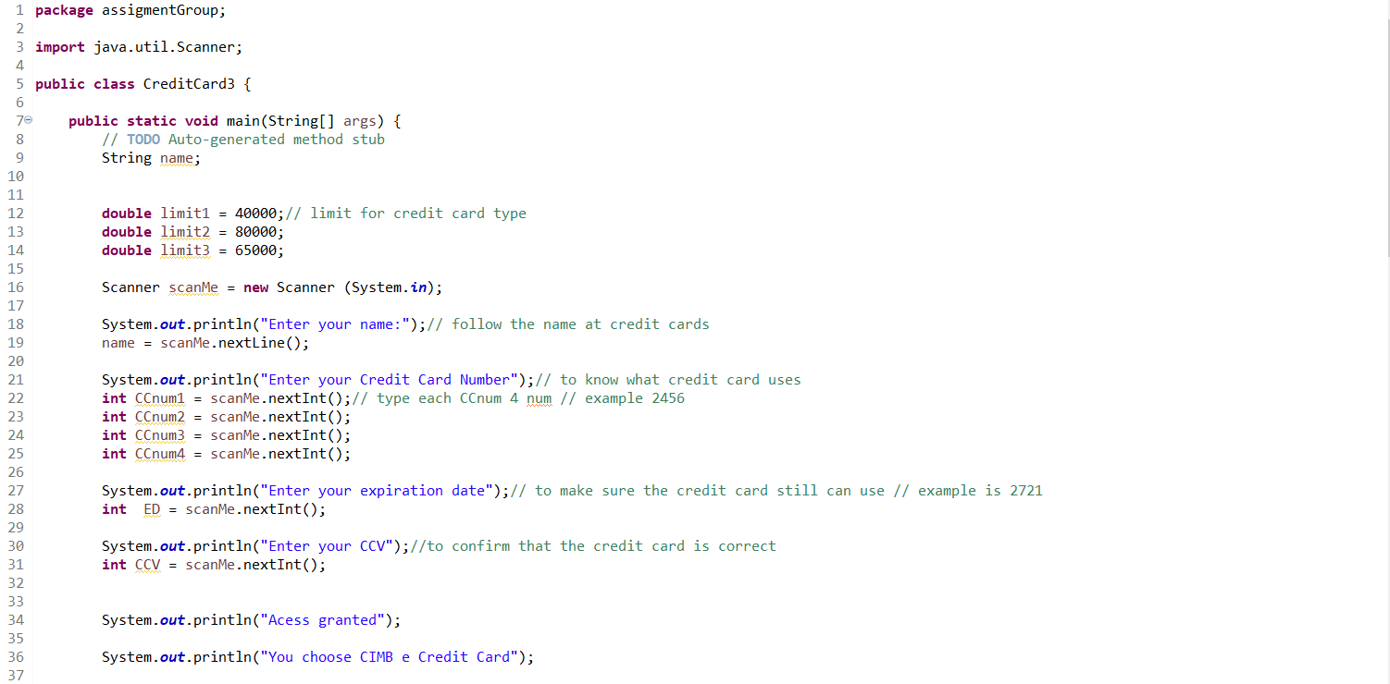

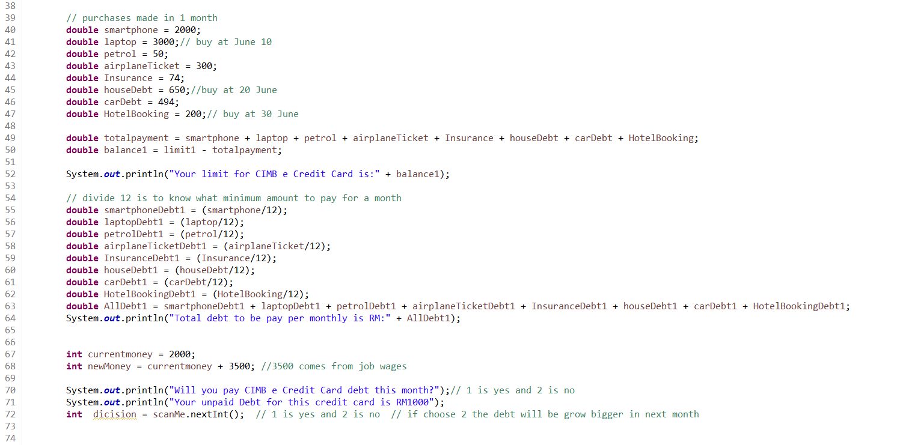

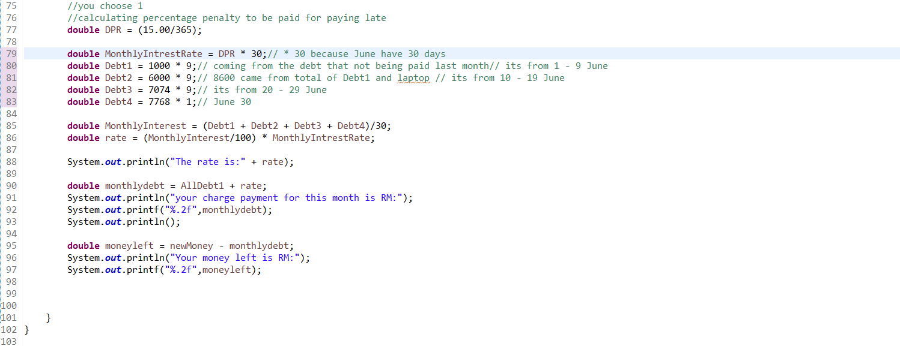

**OUTPUT:**

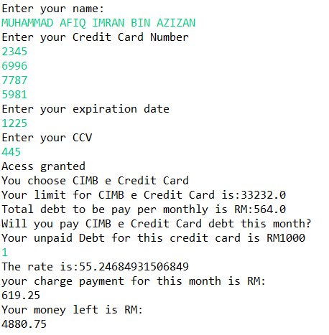



**A211 STIA1113 PROGRAMMING 1 (GROUP C)**

LECTURER : Prof. Madya Dr. Azman B Yasin

NAME : Muhammad Yasri Bin Roslan

MATRIC NUMBER : 287021

TOPIC : Bank

SUBTOPIC : Housing Loan

1. **Identify the problem**

A home loan also known as a mortgage is a contract between a borrower and a lender that allows the borrower to borrow money to purchase a home, apartment, condo, or other living property. A home loan is often repaid over 10, 15 or 30 years. The majority of people consider buying a home to be the most important financial decision they will ever make. Most people can't afford to pay cash for the entire property up front because residences can cost hundreds of thousands, if not millions, of dollars. As a result, they will need to obtain a house loan which borrow from a bank, credit union, or specialty mortgage lender for low-income borrowers such as CIMB Bank, Maybank or Bank Islam. For example Maybank is Malaysia’s largest financial services group and has a strong regional presence in South East Asia. Maybank offers a full range of financial products and services covering consumer banking, corporate and investment banking, Islamic banking, asset management, wealth management, insurance and takaful, and private banking. All of this is a importing thing to people to gain their loan to buy property or to invest for future. The situation that we can see is that new borrowers are hesitant to apply for a loan because they are unsure of how much they will have to pay if they apply for one and how much their entire total payment would be, including interest, throughout the life of the contract.

1. **Understand the problem**

Due to applicants' lack of awareness of the process, home loan applications in Malaysia have a high incidence of denial. According to Bank Negara Malaysia, home loan refusal rates reached nearly 60% last year (BNM). This is because many borrowers are uninformed of how much they can borrow and what they must remember to avoid their loan being rejected by the bank. This is a problem that many borrowers, particularly first-time borrowers, experience. The majority of them always apply for a loan based on the price of the home they want, but they overlook variables such as the amount they must repay. This is critical because when a borrower purchases a home without first calculating the amount they must repay, it can cause certain borrowers to have difficulty repaying their loans, and in some cases, this can lead to bankruptcy. . As a result, borrowers must understand how to determine the amount owed and the overall amount owed on the contract.

1. **Identify alternative ways to solve the problem**
2. Make a system calculating for help borrower to calculate their amount of payback and the total amount payback in housing loan.
3. Make system to give a information for borrower to know more about housing loan applying.
4. **Select the best way to solve the problem from the list of alternative solution**

The best way to solve this problem are first way which is make a system calculation for help borrower to calculate their amount of they need to pay. This is because when borrower know how much they need to pay for monthly so they can find a house price that suitable with they salary. Next this calculation will help a lot to borrower especially for borrower who are the first time borrow loan from the bank because it can reduce a time for borrower deal with a banker about a amount. Also when borrower buy a house that can they able to pay this can make a low risk for borrower bankrupt.

1. **List instruction that enable you to solve the problem using the selected solution**
2. Borrower need to declare some information
3. The system will help borrower to calculate the total of amount according the information in the first part
4. The system will give the total amount of payback and also they total amount in the term of contract

**The calculation**

|  |  |  |
| --- | --- | --- |
| **NO** | **LOAN TERM** | **TOTAL** |
| 1. | Principal | Rm 249,000 |
| 2. | Interest rate  3.80 / 12 / 100 | 3.80 / 12 /100  0.00031 |
| 3. | Term of years  Years * 12 | 30 * 12  360 years |
| 4. | Monthly payment  249,000 * 0.31(1+ 0.31) * 30 years  (1+ 0.31) 30 years - 1 | Rm 1160 |
| 5. | Total Payment in contract  Total monthly payment * term of years * 12 | Rm 417,684 |

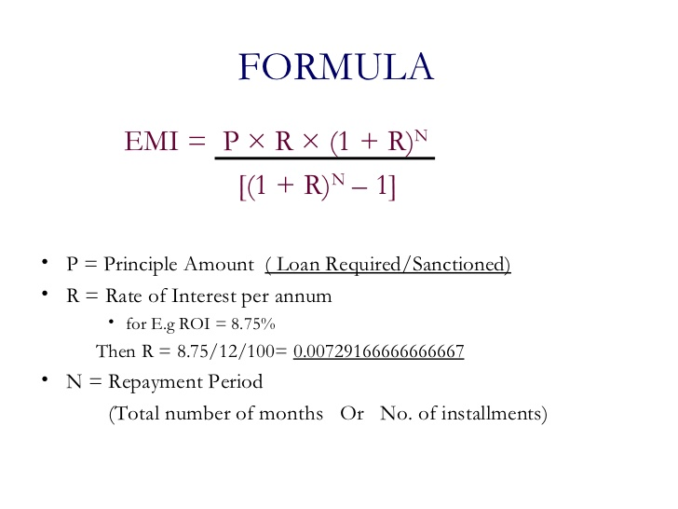

1. **Evaluate the solution**

In the end of this system will help the borrower budget planning to buy a house because they already know how much the total they need to payment. This also make a borrower feel save to apply loan to the bank.

1. Algorithm
2. Start
3. Enter the name
4. Enter the loan amount
5. Enter the interest rate
6. Enter the number of years
7. The system will calculate the monthly payment and the total of payment
8. End
9. Pseudocode
10. START
11. Read the name
12. Read the loan amount
13. Read the interest rate
14. Calculate the monthly interest rate
15. Read the number of years
16. Calculate the monthly payment = loan * monthly interest (1-monthlyinterest)*years / (1+ monthlyinterest , years)-1
17. Calculate the total payment = monthlypayment * years
18. The system will come up with the total monthly payment and the total payment
19. END
20. Flowchart

START monthlypayment * years

Declare name

Declare loan amount

Declare interest rate

Monthly interest =

interest */12/100

Declare number of years

Years *12

Calculate the monthly payment

loan * monthly interest (1-monthlyinterest)*years / (1+ monthlyinterest , years)-1

Calculate the total payment

monthlypayment * years

Print the total for monthly payment and total payment

END

1. **Coding**

**package** ASSIGNMENT1;

**import** java.util.Scanner;

**public** **class** houseLoan {

**public** **static** **void** main(String[] args) {

// **TODO** Auto-generated method stub

Scanner sc = **new** Scanner(System.***in***);

System.***out***.println("===== MAYBANK HOUSING LOAN CALCULATOR ======");

System.***out***.println("\nENTER YOUR FULL NAME : ");

String name = sc.nextLine();

System.***out***.println("\nENTER THE LOAN AMOUNT : ");

**double** loan =sc.nextDouble();

System.***out***.println("\nENTER THE INTERST RATE : ");

**double** interest = sc.nextDouble();

**double** monthlyinterest = interest /(12*100);

System.***out***.println("\nENTER THE NUMBER OF YEARS : ");

**double** time = sc.nextDouble();

**double** years = time * 12;

**double** monthlypayment= (loan*monthlyinterest*Math.*pow*(1+monthlyinterest,years))/(Math.*pow*(1+monthlyinterest,years)-1);

**double** totalpayment = monthlypayment * years;

System.***out***.println("\n*-*-*-*YOUR TOTAL MONTHLY PAYMENT AND TOTAL PAYMENT*-*-*-*");

System.***out***.println("\nTHE TOTAL MONTHLY PAYMENT IS RM "+ (Math.*round*(monthlypayment)));

System.***out***.println("\nTHE TOTAL PAYMENT IS RM " + (Math.*round*(totalpayment)));

System.***out***.println("\nTHANK YOU FOR USING MAYBANK CALCULATOR " + name );

sc.close();

}

}

**Output**

===== MAYBANK HOUSING LOAN CALCULATOR ======

ENTER YOUR FULL NAME :

MUHAMMAD ZARUL BIN ZAKIR

ENTER THE LOAN AMOUNT :

249000

ENTER THE INTERST RATE :

3.80

ENTER THE NUMBER OF YEARS :

30

*-*-*-*YOUR TOTAL MONTHLY PAYMENT AND TOTAL PAYMENT*-*-*-*

THE TOTAL MONTHLY PAYMENT IS RM 1160

THE TOTAL PAYMENT IS RM 417684

THANK YOU FOR USING MAYBANK CALCULATOR MUHAMMAD ZARUL BIN ZAKIR



**A211 STIA1113 PROGRAMMING 1 (GROUP C)**

LECTURER : Prof. Madya Dr. Azman B Yasin

NAME : Muhamad Aimil Daniel Bin Latif

MATRIC NUMBER : 287056

TOPIC : Bank

SUBTOPIC : Investment

1. **Identify the Problem**

An asset or object purchased with the intention of generating income or appreciation is referred to as an investment. The term "appreciation" refers to an asset's value increasing over time. When a person buys something as an investment, the goal is not to consume it but to utilise it to build wealth in the future. The purpose of investing is to generate income and increase the value of an asset over time. Any technique for earning future revenue might be referred to as an investment. This involves, for example, the acquisition of bonds, stocks, or real estate property. Buying a property that can be used to manufacture things may also be considered an investment.

In general, any action that is taken in the hopes of raising future revenue can also be considered an investment. For example, when [choosing to pursue additional education](https://www.investopedia.com/articles/basics/11/3-s-simple-investing.asp), the goal is often to increase knowledge and improve skills (in the hopes of ultimately producing more income). Because investing is oriented toward the potential for future growth or income, there is always a certain level of risk associated with an investment. An investment may not generate any income, or may actually lose value over time. For example, it's also a possibility that you will invest in a company that ends up going bankrupt or a project that fails to materialize. This is the primary way that saving can be differentiated from investing: saving is accumulating money for future use and entails no risk, whereas investment is the act of leveraging money for a potential future gain and it entails some risk.

There are four main investment types which are growth investment, shares, property, defensive investments, cash and fixed interest. Growth investments are more suitable for long term investors that are willing and able to withstand market ups and downs. Shares are considered a growth investment as they can help grow the value of your original investment over the medium to long term. If you own shares, you may also receive income from dividends, which are effectively a portion of a company’s profit paid out to its shareholders. Of course, the value of shares may also fall below the price you pay for them. Prices can be volatile from day to day and shares are generally best suited to long term investors, who are comfortable withstanding these ups and downs. Also known as equities, shares have historically delivered higher returns than other assets, shares are considered one of the riskiest types of investment. Property is also considered as a growth investment because the price of houses and other properties can rise substantially over a medium to long term period. However, just like shares, property can also fall in value and carries the risk of losses. It is possible to invest directly by buying a property but also indirectly, through a property investment fund. For defensive investments, these are more focused on consistently generating income, rather than growth, and are considered lower risk than growth investments. Cash investments include everyday bank accounts, high interest savings accounts and term deposits. They typically carry the lowest potential returns of all the investment types. While they offer no chance of capital growth, they can deliver regular income and can play an important role in protecting wealth and reducing risk in an investment portfolio. The best-known type of fixed interest investments are bonds, which are essentially when governments or companies borrow money from investors and pay them a rate of interest in return. Bonds are also considered as a defensive investment, because they generally offer lower potential returns and lower levels of risk than shares or property. They can also be sold relatively quickly, like cash, although it’s important to note that they are not without the risk of capital losses.

As mentioned, investing is putting money to work in order to grow it. When you invest in stocks or bonds, you are putting that capital to work under the supervision of a firm and its management team. Although there is some risk, that risk is rewarded with a positive expected return in the form of capital gains and/or dividend & interest flows. Cash, on the other hand, will not grow, and may very well lose [buying power](https://www.investopedia.com/terms/b/buyingpower.asp) over time due to inflation. Put simply, without investment, companies would not be able to raise the capital needed to grow the economy.

Since my topic is about investment, I had found that CIMB Islamic Bank Berhad offers many investment products. CIMB Group Holdings Berhad is a Malaysian universal bank headquartered in Kuala Lumpur and operating in high growth economies in ASEAN. CIMB Group is an indigenous ASEAN investment bank and CIMB has a wide retail branch network with 1,080 branches across the region.

So, this are the some types of investment in CIMB Islamic Bank Berhad :

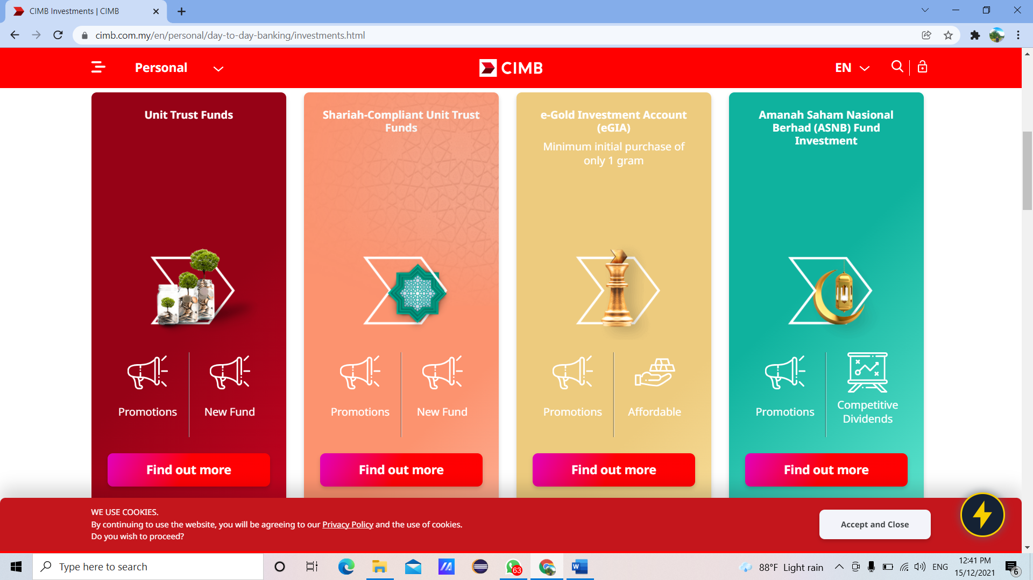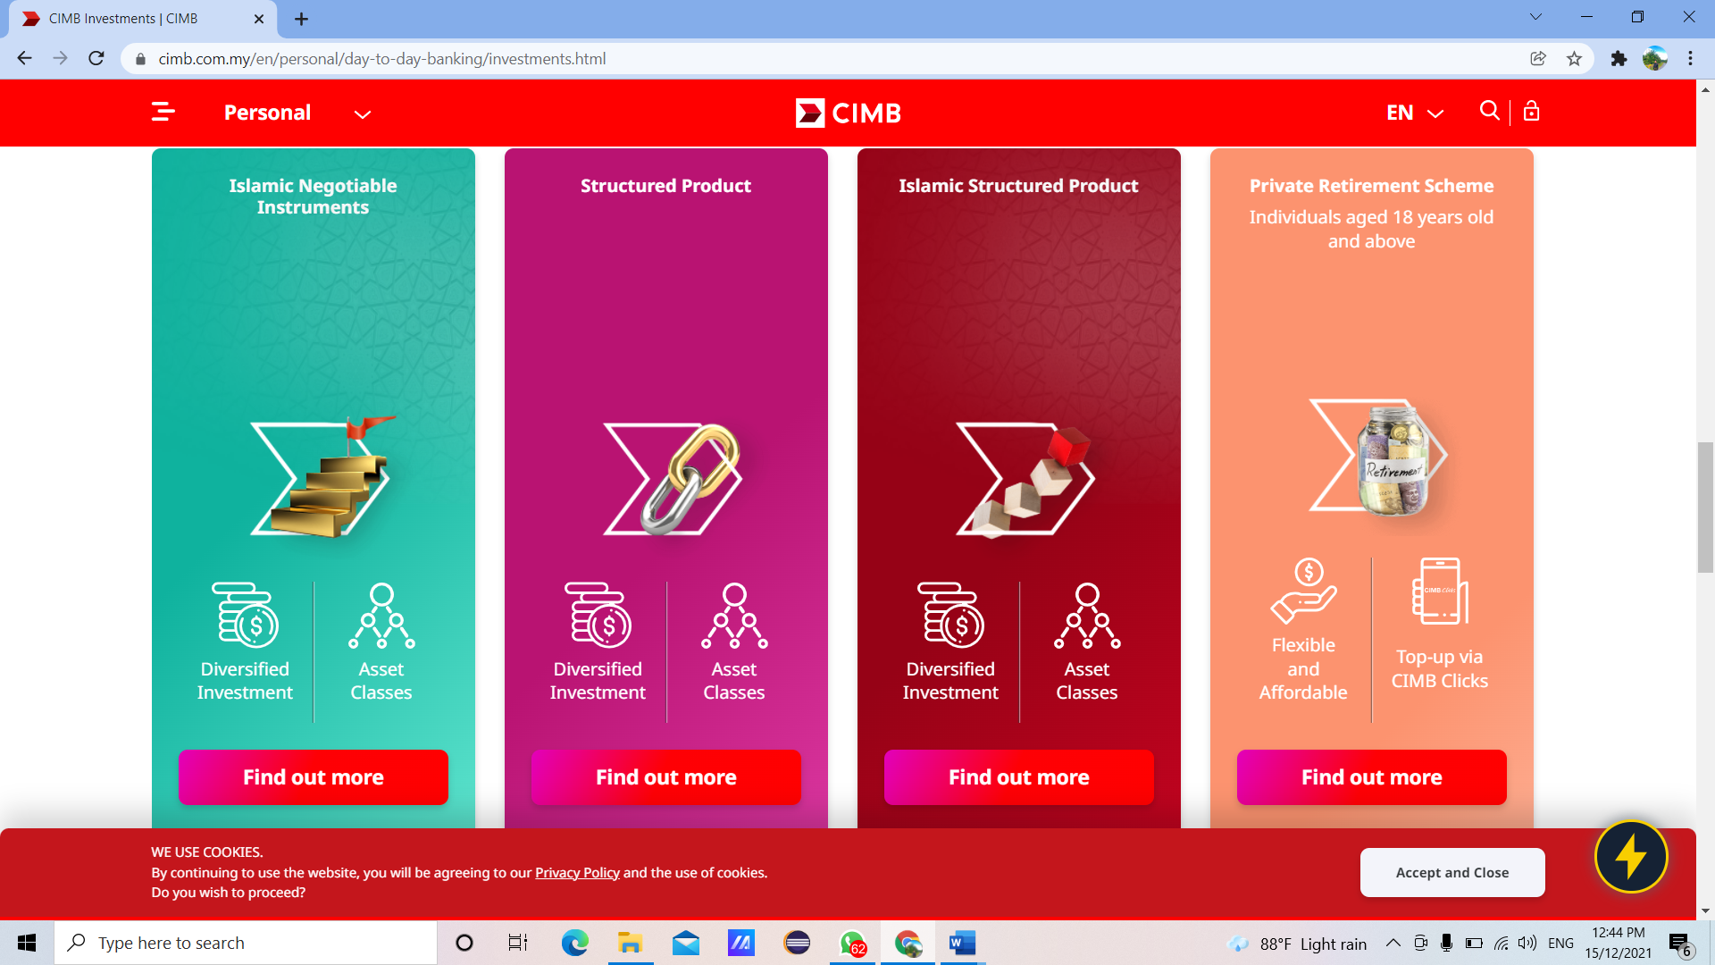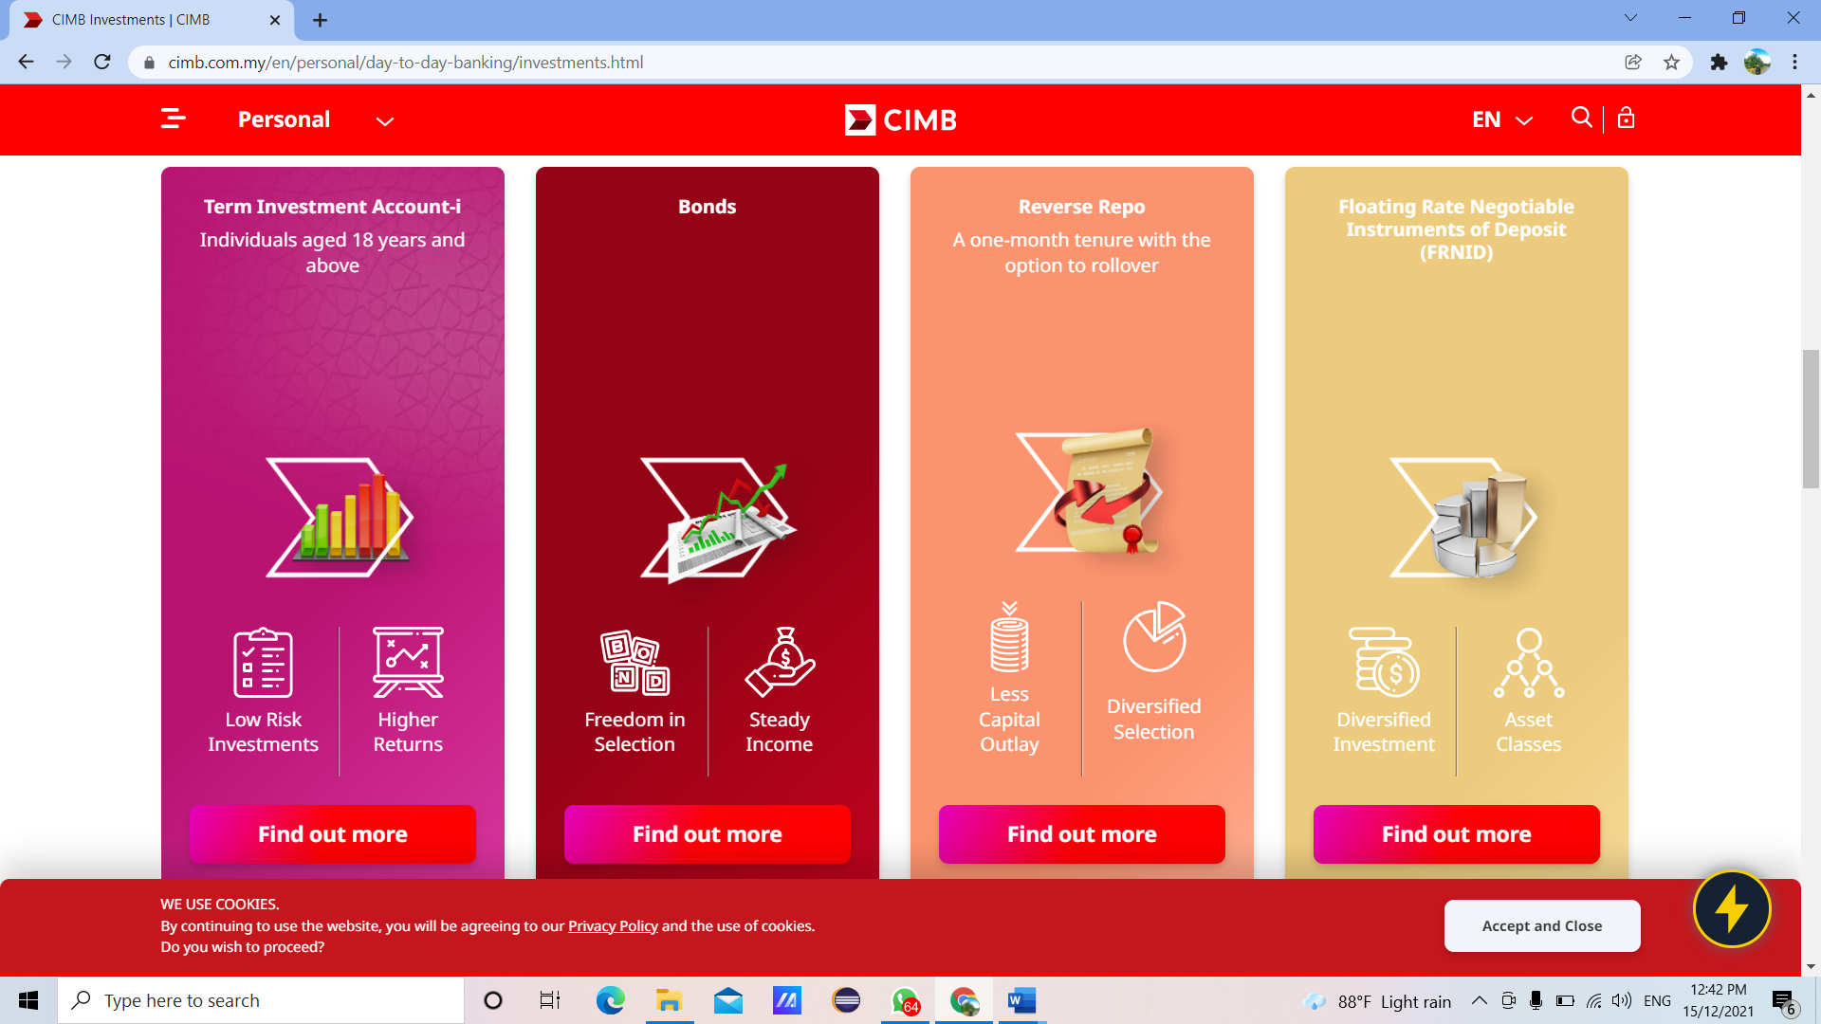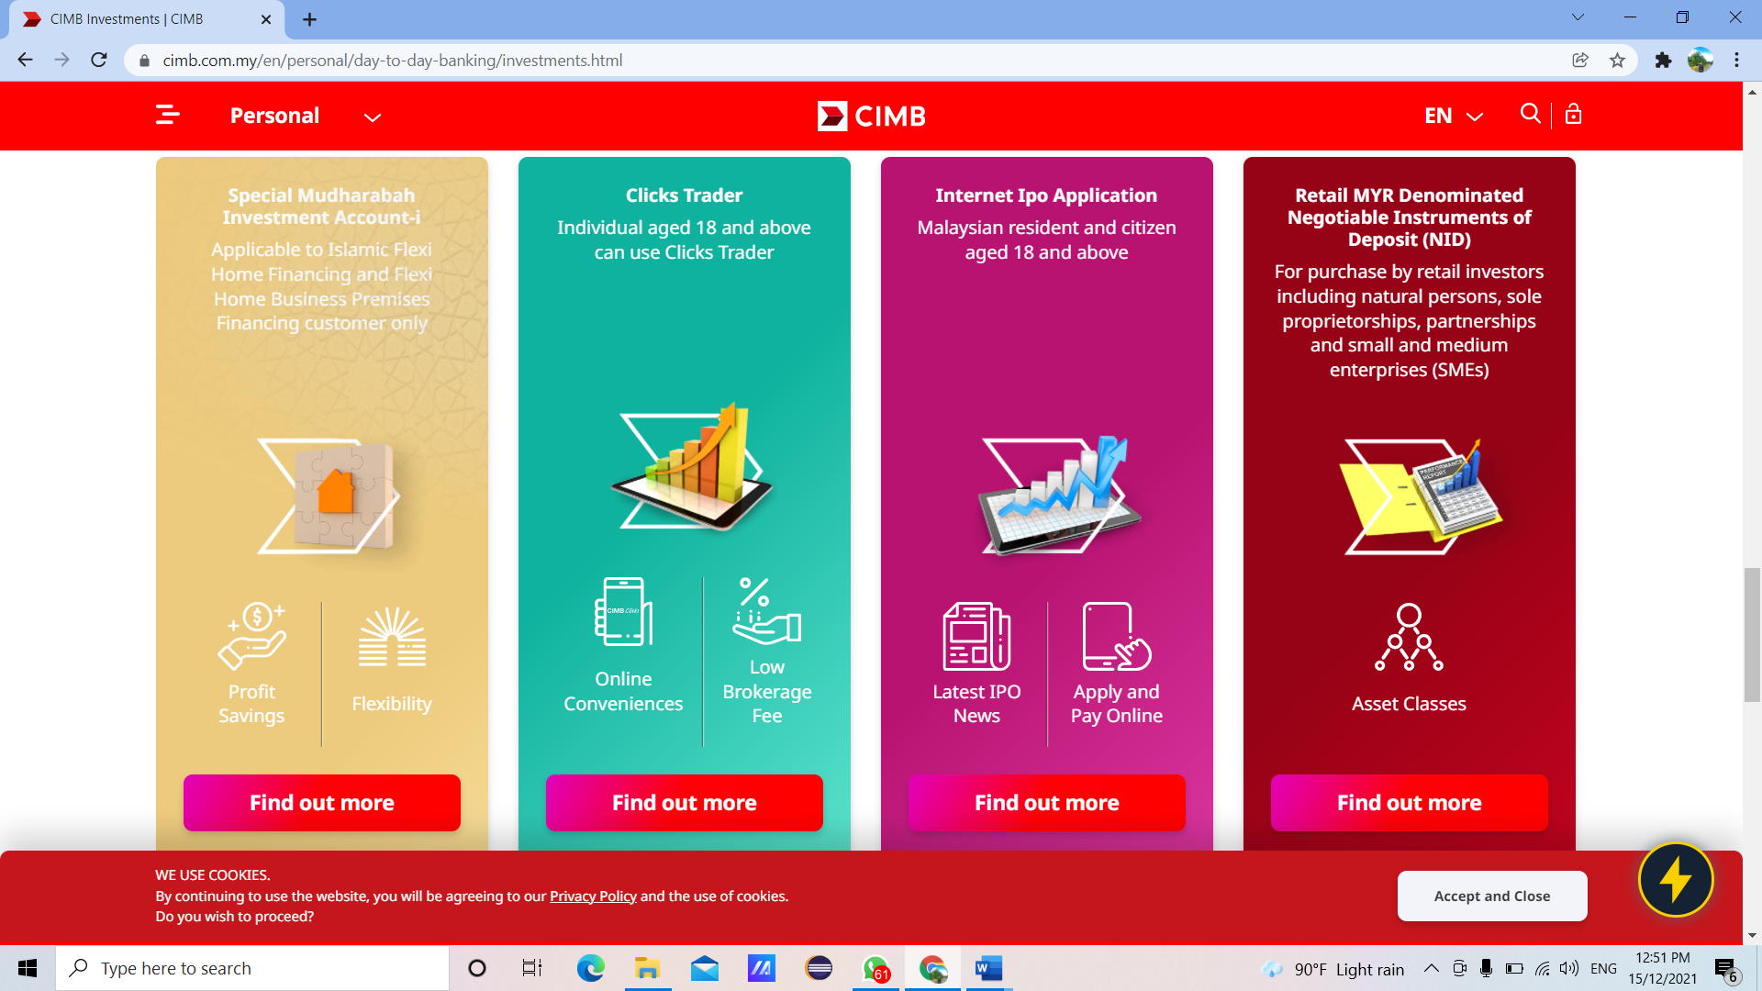 

Now we are living in this pandemic, so some of the residents in Malaysia had to face with financial problem. I would think that the investment suggest by CIMB are the one which can help with this financial problem.

1. **Understand the problem**

The Covid-19 pandemic has affected the income of the population. This has caused the savings to dwindle. So, they're looking for ways to raise their savings. Therefore, CIMB Islamic Bank Berhad has introduced an investment scheme known as Term Investment Account-i. This investment account offers high return potential and no fees. The minimum investment placement per account holder will be RM1,000 for 3, 6- and 12-months tenure for individual. Actual returns will be declared based on the actual performance of the investment. However, inexperienced new investors do not know on how to calculate the profit that they will get after the investment. Furthermore, this system will assist and help them without having them to go to CIMB and asking for solution from the bank officer.

1. **Identify Alternative Ways to Solve the Problem**

1. Build a system that can automatically calculate profitability.

2. Put dividend rates and give investors self-calculating profits without assist.

1. **Select the Best way to solve the Problem From the List of Alternative Solutions**

The best way is number first one which is built a system that can automatically calculate profitability. Hence, this system will show step by step on what investors have to do. In that system, it will give some information that customer needs to know. So, this will be easier for the investors to know about their progress on the investment.

1. **List Instructions that Enable you to Solve the Problem Using the Selected Solution**
2. Ask user to key in their name, number phone and account number.
3. Ask user to choose 1
4. The system will display the information of Term Investment account-i.

(Table 1)

1. Enter Investment Amount, Investment Tenure and percentage of Net Return to customer.
2. Wait for the system to calculate the amount of profitability.
3. The system will display the name, number phone, account number, profit payable to the Customer, accumulated profits and total amount.

|  |  |  |  |
| --- | --- | --- | --- |
|  | **Package A** | **Package B** | **Package C** |
| Investment Amount | Rm 1,000- Rm 10,000 | Rm 10,001- Rm 30,000 | Rm 30,001- Rm 60,000 |
| percentage of Net Return to customer | 3.2% | 3.8% | 4.2% |

**Table 1**

**Formula**

- Profit payable to cust = Investment amount * Percentage of return to customer * 30/365

- Accumulated profit = Profit payable to cust * investment tenure

- Total amount = Investment amount + accumulated profit.

|  |  |
| --- | --- |
| Investment amount | RM30000 |
| Percentage of return to customer | 3.80% |
| Investment tenure | 3 months |

Calculation:

* Profit payable to cust = Rm 30,000 x 4.20% x 30/365 = Rm 96.82
* Accumulated profit = Rm 96.82 x 3 = Rm 290.46
* Total amount = Rm 30,000 + RM 290.46 = Rm 30,290.46

**6. Evaluate the Solution**

In the end by using this system will help the investor to solve problem and will easier for he/she to understand. Hence, the system is easy to access and can use anywhere and anytime. This system will show the output that actually they want. This system is more suitable according to this time which is Pandemic Covid-19. By using this system, this will help them to save their time and do not have to make appointment with the bank.

**7. ALGORITHM**

1. Start
2. Enter name, phone number, account number.
3. Select investment.
4. Enter investment amount, investment tenure and percentage of return to customer.
5. System calculate the input.
6. Display customer name, phone number, account number, profit payable to cust, accumulated profits and total amount.
7. End

**8. PSEUDOCODE**

1. Start
2. INPUT name, phone_number, and acc_number
3. INPUT Select Investment
4. INPUT invest_amount, invest_tenure, percent
5. profitpayabletocust = invest_amount * percent * 30/365
6. accumulatedprofit = profitpayabletocust * invest_tenure
7. totalamount = invest_amount + accumulatedprofit.
8. OUTPUT “NAME” and name, “PHONE NUMBER” and phone_number, “ACCOUNT NUMBER” and Account Number
9. OUTPUT “PROFIT PAYABLE TO CUSTOMER” and profitpayabletocust, “ACCUMULATED PROFIT” and accumulatedprofit, “TOTAL AMOUNT” and totalamount
10. End

**9. FLOWCHART**



**10.Coding – Numerical Computation & Expression**

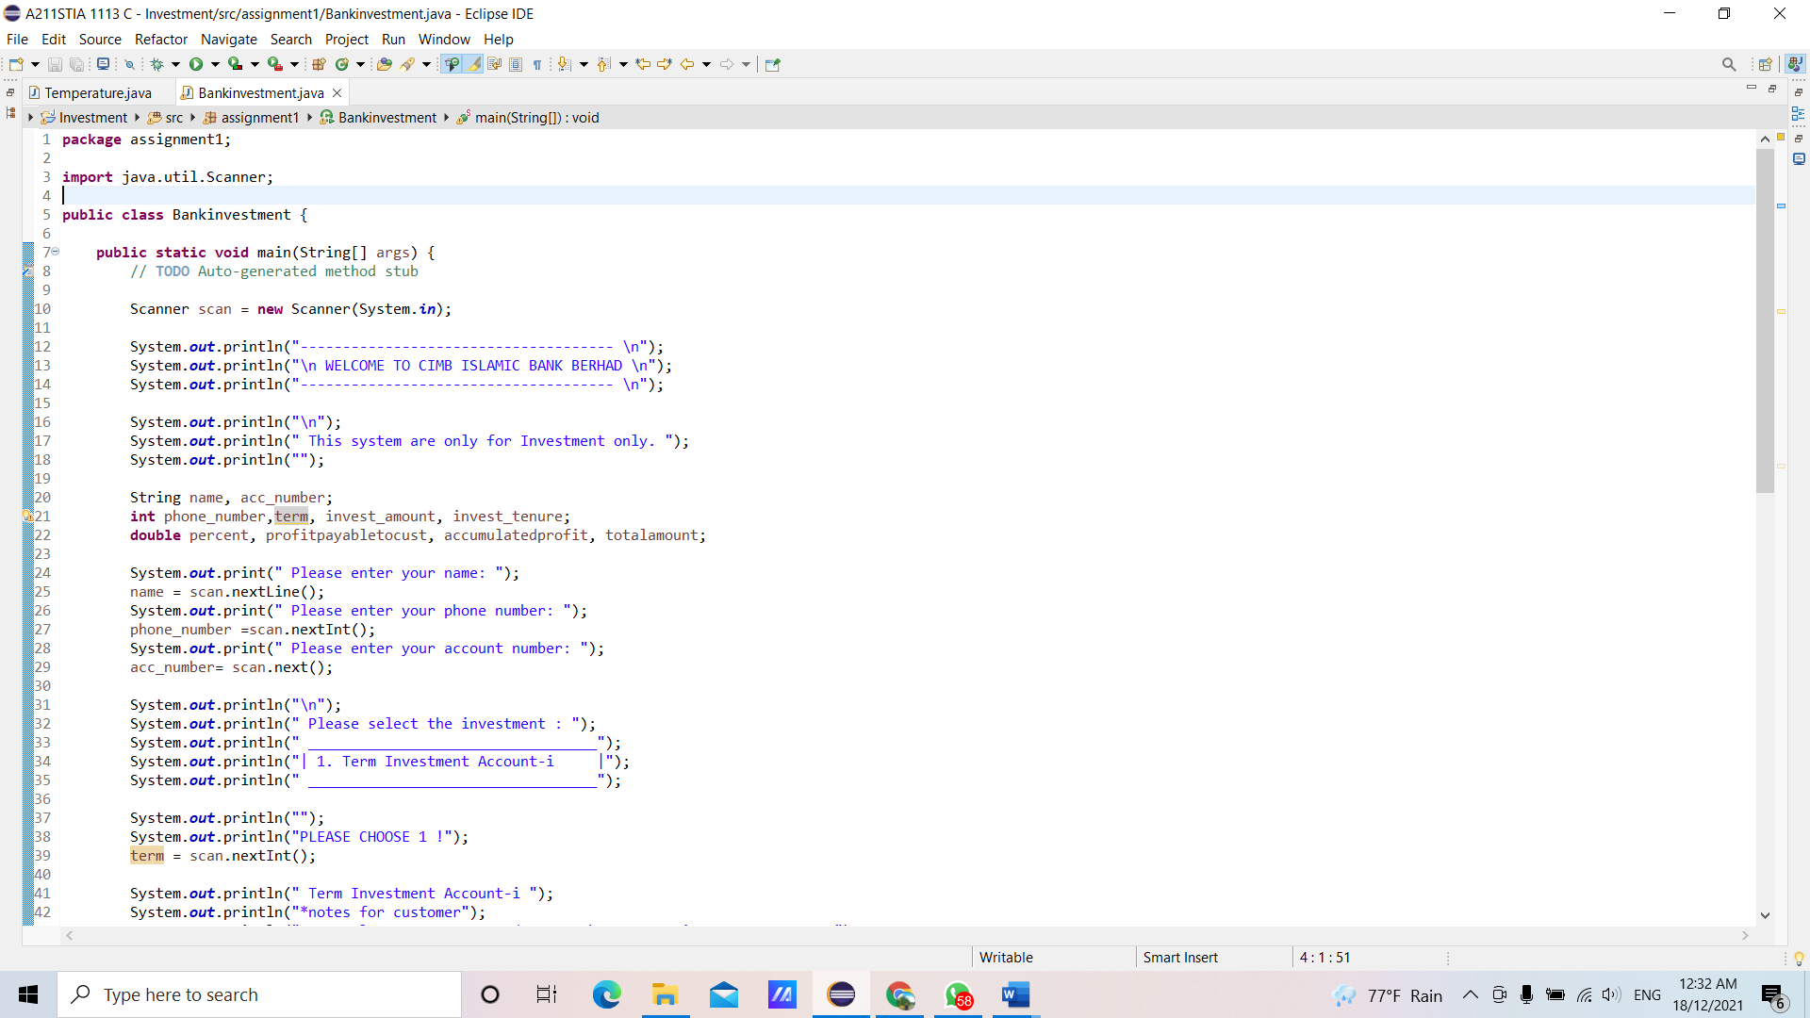

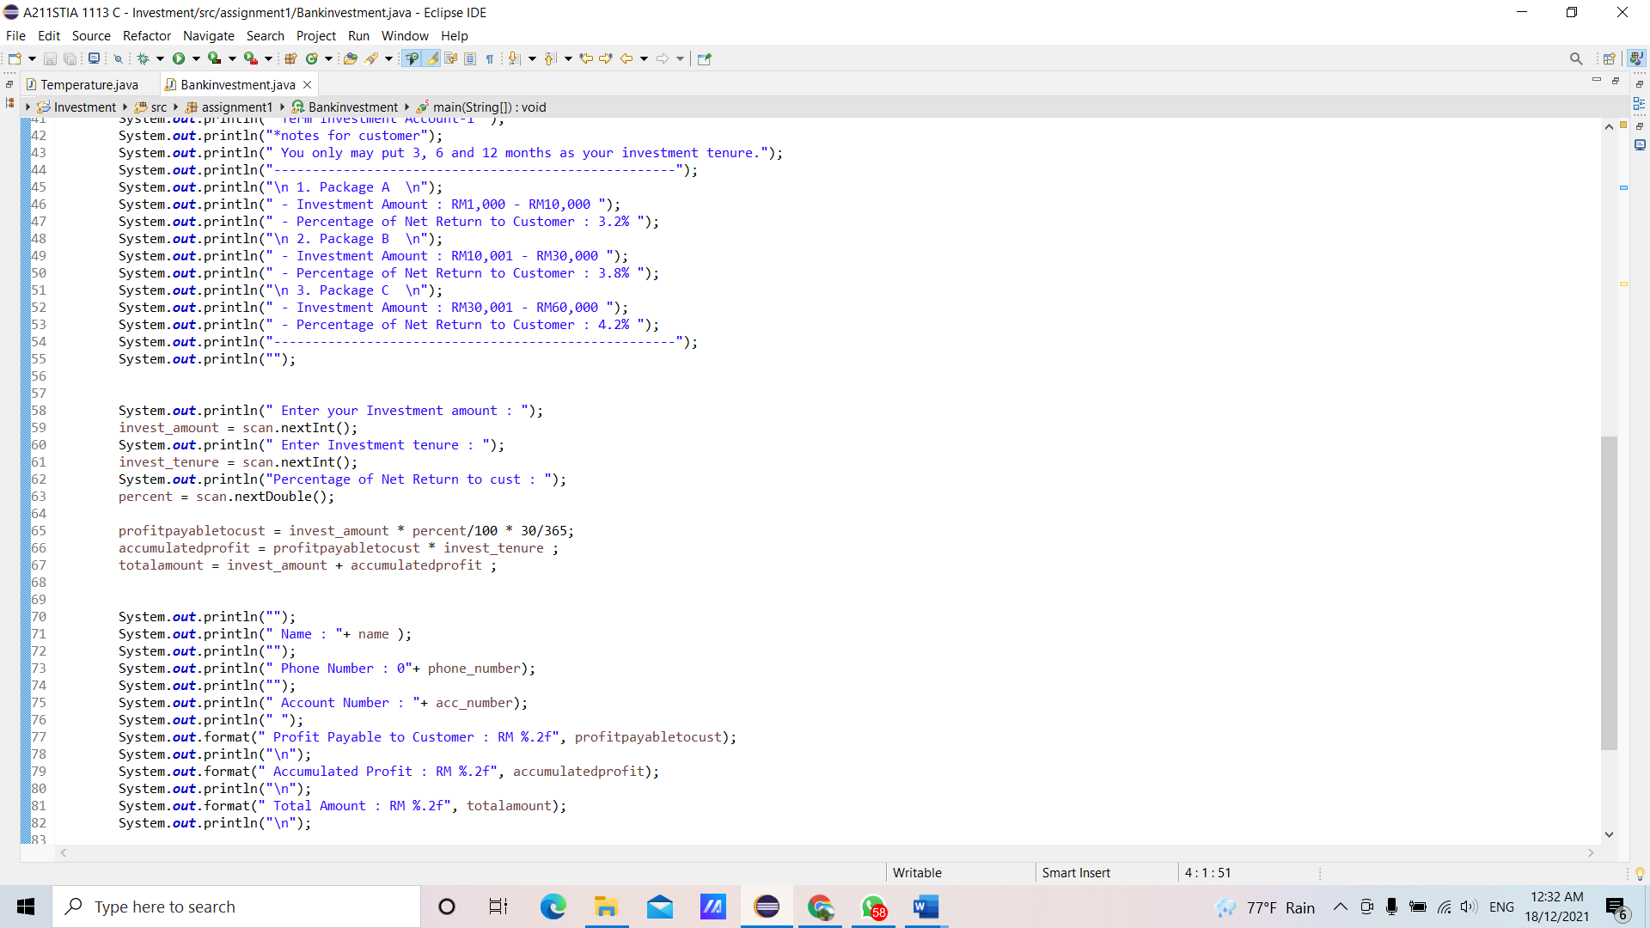

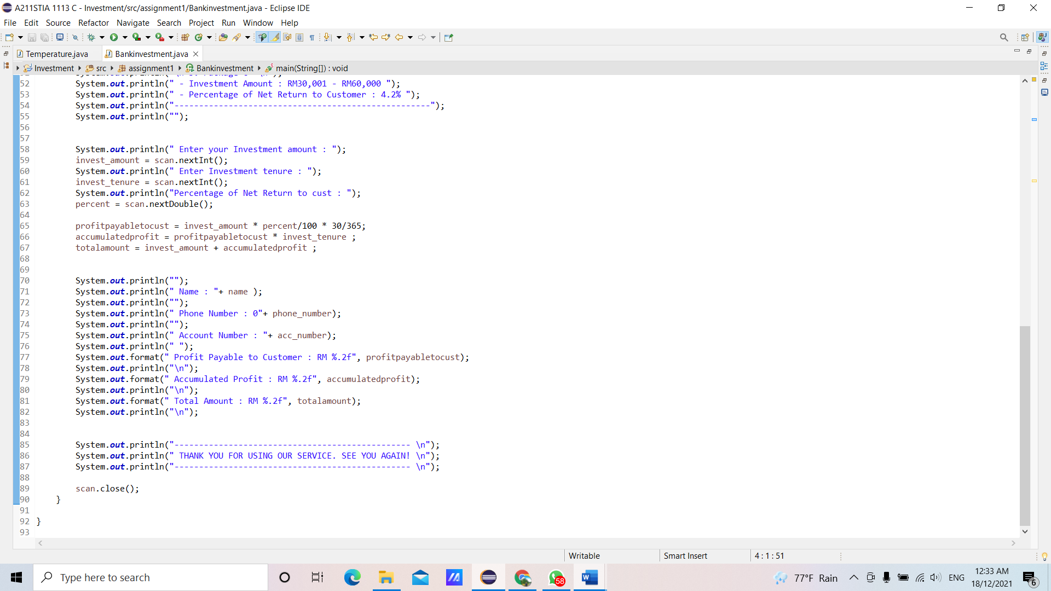

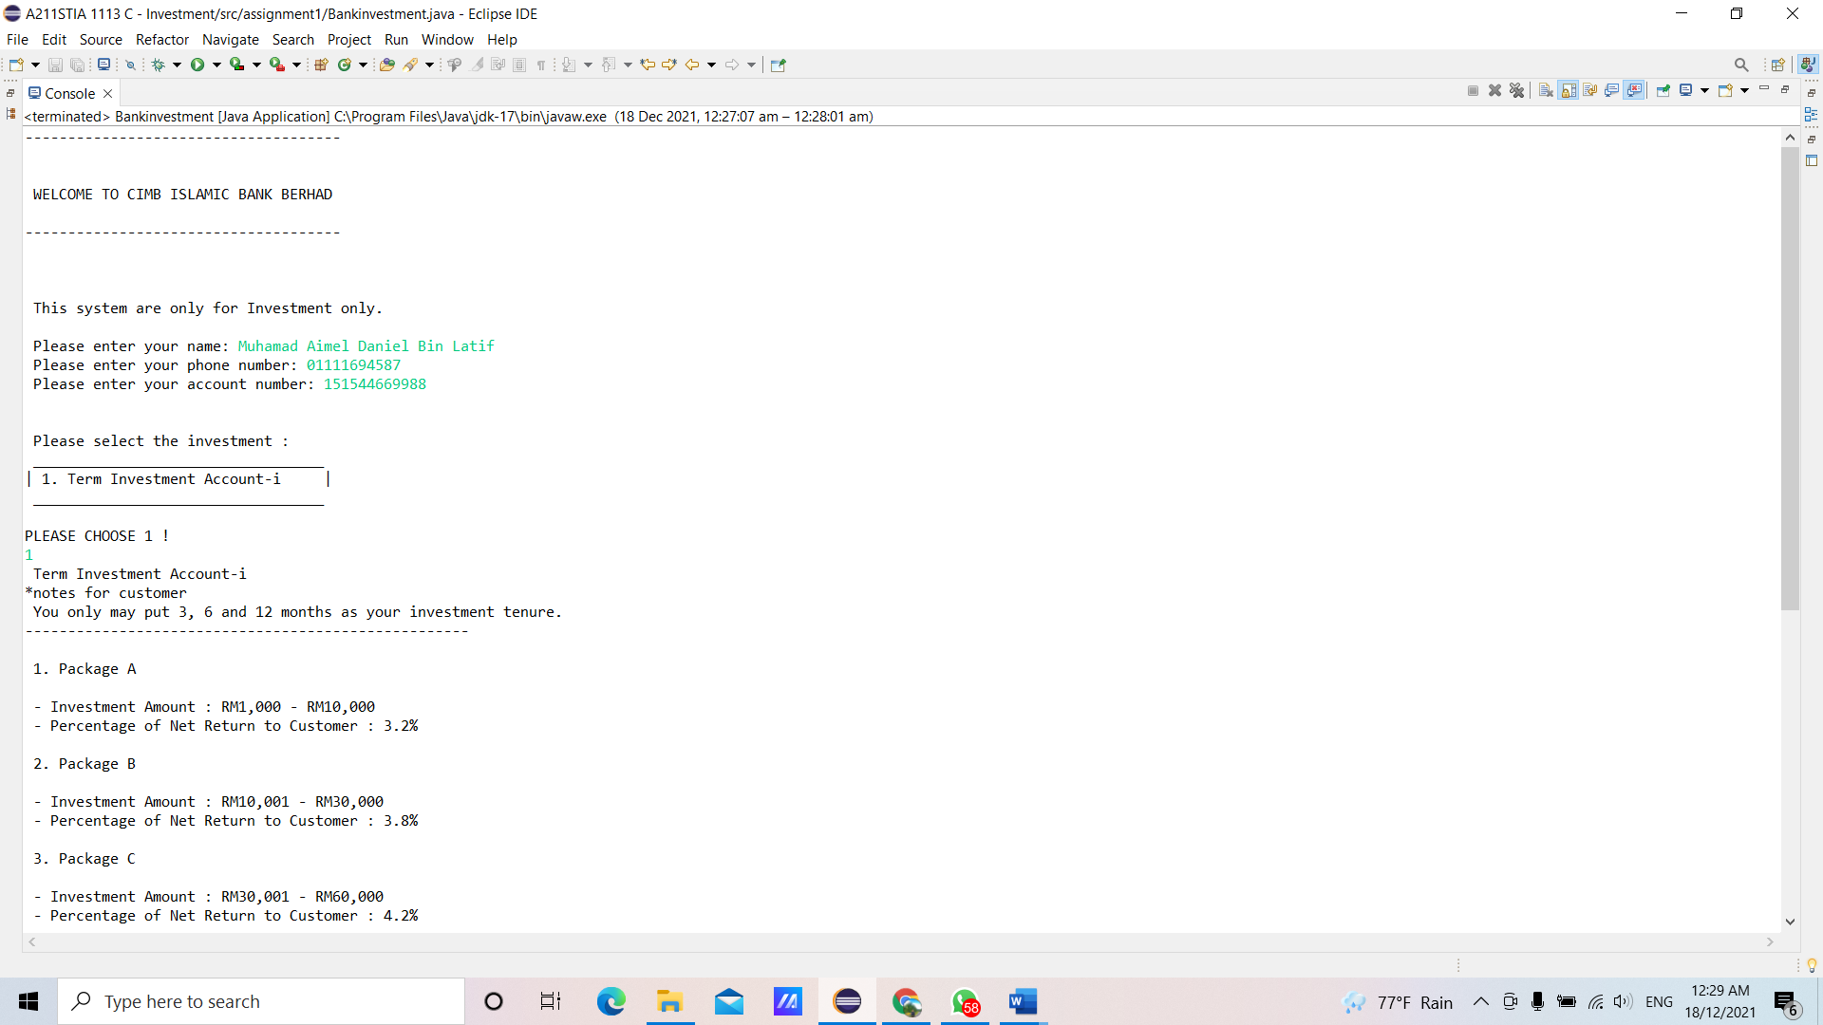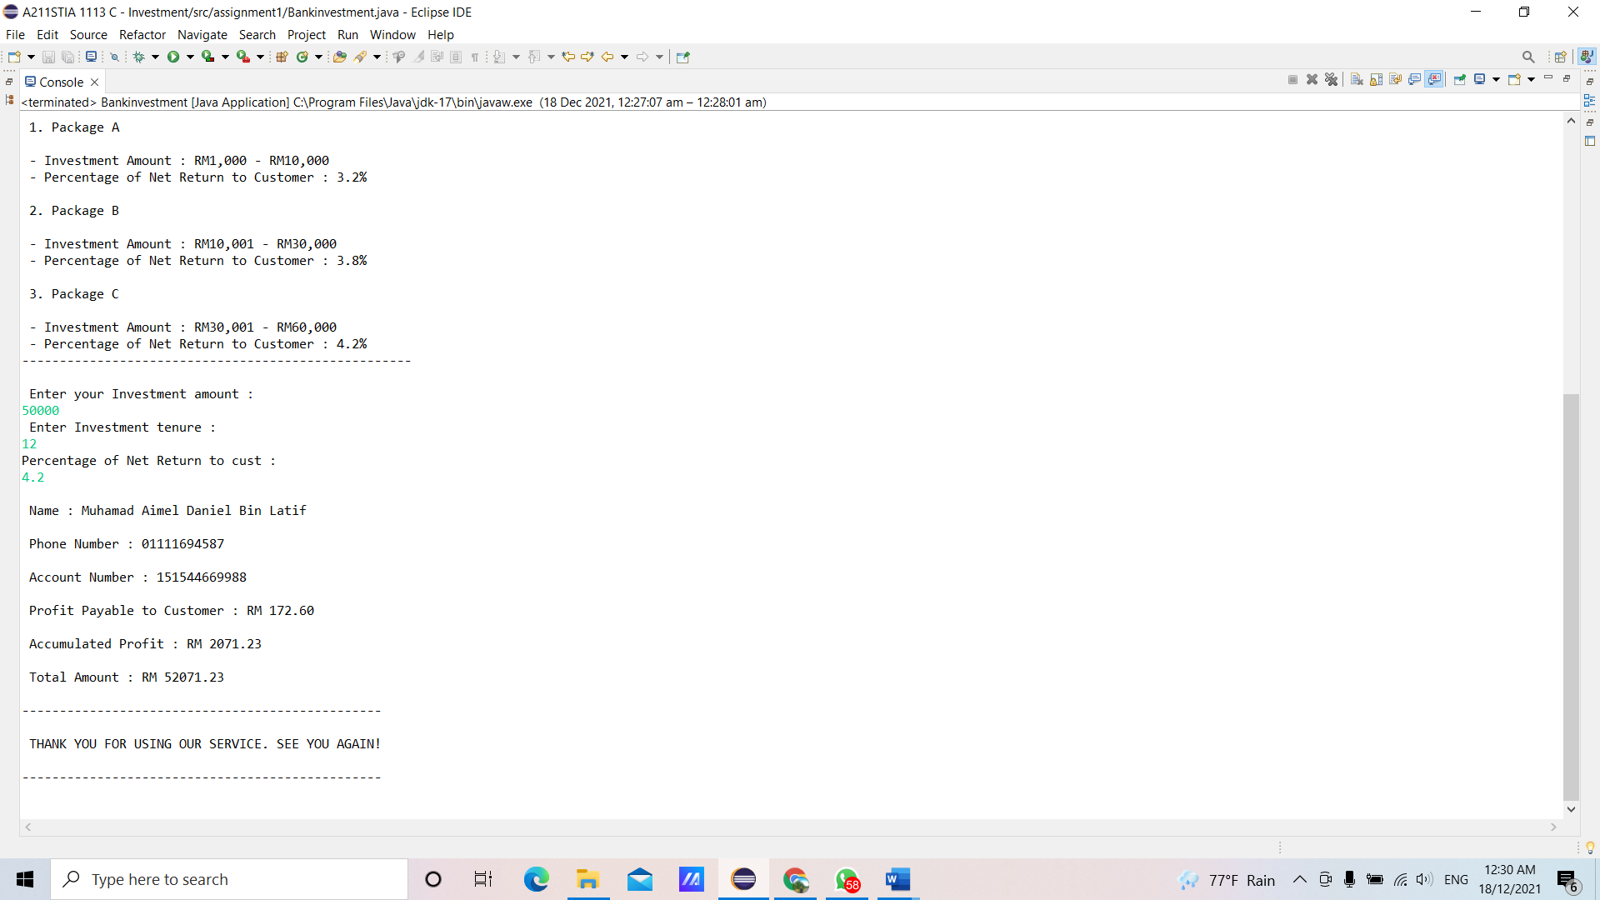

**References:**

1. CIMB Investment. Retrieved from https://www.cimb.com.my/en/personal/day-to-day-banking/investments.html
2. Adam Hayes. (2021, August, 20). *Investment. What is an Investment?* Retrieved from https://www.investopedia.com/terms/i/investment.asp
3. Siwe Geck, Kwang Hooi, Zaliha & Fatimah. (2016) *SAINS KOMPUTER TINGKATAN 4.* Oxford Fajar Sdn. Bhd.